**Teacher Notes:**The Great Barrier Reef is the largest coral reef system in the world.

* It is found in the Coral Sea, off the coast of Queensland, Australia.
* The Great Barrier Reef is the **world’s largest living structure.**
* It is made up of around 2900 individual reefs and 900 islands.
* The Great Barrier Reef is around 2600 kilometres (1616 miles) in length.
* Astronauts can see the Great Barrier Reef from space.
* Marine animals called coral play an important role in the formation of the Great Barrier Reef.
* Coral create calcium carbonate which forms a hard, shell-like skeleton.
* The Great Barrier Reef is home to a wide range of life, including fish, sea turtles, giant clam, seahorse, sea snakes, nudibranch, sea turtles, stingray, sharks and many more.
* Over **1500 different species of fish live** in the Great Barrier Reef, **including clownfish, star of the animated film Finding Nemo.**
* Whales, dolphins and dugong can also be seen in the Great Barrier Reef.

### **Threats to the Great Barrier Reef dying?**

The Great Barrier Reef is being overwhelmed by so many different threats. The biggest problem is caused by **global warming** and the burning of fossil fuels. In particular, **coral bleaching** has been devastating the reef in the span of just a few years. This year and last year, the Great Barrier Reef experienced severe bleaching. The reefs are composed of a calcium carbonate exoskeleton that hosts colonies of hundreds of thousands of polyps. The corals have a symbiotic relationship with zooxanthellae, which provide nutrition and give the reefs their bright colours. When the oceans get too warm, the coral polyps are stressed and kick out the zooxanthellae. They lose their food source and colouring, and therefore look white, hence the term bleaching. Bleaching doesn’t kill corals by itself but weakens the corals and makes them vulnerable to disease. The reefs can’t live forever like this and die if conditions don’t improve.

A reef can survive bleaching if it has time to recover. Unfortunately, the Great Barrier Reef hasn’t had a chance so far. Last year there was an El Niño, which was expected to cause bleaching because it warms water. However, this year, there was still severe bleaching. Aerial surveys have found that two-thirds of the reef have been affected by the bleaching; a 1,500 stretch of the reef. Only the reef’s southern third is more or less undamaged, though 91% of the whole reef show some signs of bleaching. Think about this — the reef has only experienced mass bleaching four times in total, 1998, 2002, 2016, 2017, and twice of those have been in the past two years. The corals could recover, but they need more time— about 10 years for fast-growing corals. If the bleaching continues to occur at its current rate, then the reefs won’t be able to recover.

**[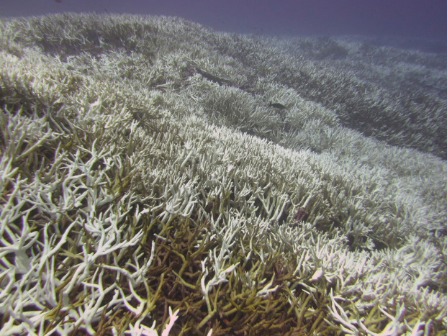](https://cdn.zmescience.com/wp-content/uploads/2017/06/image13_03_med.jpg)*A bleached coral reef.***

Not only does do the warming waters affect the coral reef, but so does emitted **carbon dioxide**. When carbon dioxide enters the ocean, it dissolves. The ocean has removed about a third of the **CO2** from the atmosphere. This is good in a way because it takes away some of the CO2 that would contribute to the greenhouse effect, but it has a negative side on the ocean. As the concentration of carbon dioxide in the ocean increases, the ocean’s pH decreases and becomes more acidic. This higher acidity prevents corals from absorbing the calcium carbonate that they need to maintain their exoskeletons. Already, the ocean is **30% more acidic than in was in 175**1 (pH change from 8.179 to 8.069). If we continue to produce carbon dioxide like we do now, the pH could get as low as 7.8. Studies have shown that this acidity could dissolve the skeletons of corals and make reefs fall apart. So the use of fossil fuel presents a two-pronged problem to coral reefs with bleaching and acidity.

Unfortunately, that’s not even the end of what the reefs are up against. Although **regulated, fishing and tourism can damage and stress the reefs. An invasive starfish, the crown-of-thorns,** is rampant and hungry. The large populations of the starfish feasts on the reef, damaging it. Recently, a slew of toxic chemicals were found in sea turtles, such as medications, pesticides, and metals. These are being leaked by humans onshore and likely affect the health of the whole reef. The southern part of the reef also underwent physical damage (yes, the only part not really affected by bleaching) by the cyclone Debbie this past year. There could even be other stressors that we know or don’t know about (like pollution, etc).

### **Why we need it**

The Great Barrier Reef is the largest living structure on Earth. Coral reefs are important for providing many essential services for humans and for **biodiversity**. It supports a tremendous amount of biodiversity for taking up a relatively small part of the ocean. Coral reefs make up only 0.1% of the ocean floor and host millions of species. Many organisms breed, nurse, and feed in coral reefs. This diversity is beneficial to us because it gives us lots of tasty seafood to eat. Fish from coral reefs feed over a billion people worldwide. We might not even know all of the benefits. For example, many animals and plants in coral reefs produce chemicals that could be important as **medicine.** However, we know almost nothing about them. Maintaining the diversity could be important for finding a future cure for a disease.

One underrated service that the Great Barrier Reef provides is by protecting the shoreline. It keeps storms from causing damage to houses and people. The reef does this by absorbing most of the force of oncoming waves and protect shorelines. It keeps beaches looking nice and from sand being washed away or eroded. The Reef protects a large chunk of the Australian coast (about 2,300 km), Australia would have to pay a lot to keep their shorelines and beaches from being washed away if the reef goes. The Great Barrier Reef is also important as a tourism destination as scuba divers and snorkelers visit them. Even more people visit the beaches that are protected by the reefs.

[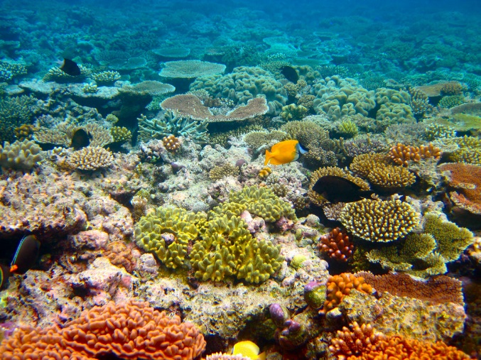](https://cdn.zmescience.com/wp-content/uploads/2017/06/4875021166_767022cbc8_b.jpg)

***A healthy reef supports a lot of diversity and is beautiful to see!***

One underrated service that the Great Barrier Reef provides is by protecting the shoreline. It keeps storms from causing damage to houses and people. The reef does this by absorbing most of the force of oncoming waves and protect shorelines. It keeps beaches looking nice and from sand being washed away or eroded. The Reef protects a large chunk of the Australian coast (about 2,300 km), Australia would have to pay a lot to keep their shorelines and beaches from being washed away if the reef goes. The Great Barrier Reef is also important as a tourism destination as scuba divers and snorkelers visit them. Even more people visit the beaches that are protected by the reefs.

**Medicine**

Coral reefs are often referred to as the **medicine chests of the sea**. A number of creatures found on reefs produce chemical compounds that have been isolated for human applications—and many more are yet to be discovered. Scientists have developed treatments for cardiovascular diseases, ulcers, leukaemia, lymphoma, and skin cancer, all from chemicals in reef plants and animals. Other compounds reduce inflammation, kill viruses, and relax muscles.

**Why we should save the Reef continued?**

* **The reef is a global treasure because it is home to more than: 1,500 species of fish;**
* 411 types of hard coral;
* One-third of the world’s soft corals;
* 134 species of sharks and rays;
* six of the world’s seven species of threatened marine turtles; and

more than 30 species of marine mammals, including the vulnerable dugongs.

**Recommended Video links:**

[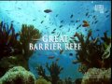](https://www.youtube.com/watch?v=X3kPgbPPqvQ)

[Great Barrier Reef](https://www.youtube.com/watch?v=X3kPgbPPqvQ)

[YouTube video](https://www.youtube.com/watch?v=X3kPgbPPqvQ)

[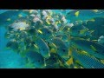](https://www.youtube.com/watch?v=Wc6S73Oe8h0)

[Caring for the Great Barrier Reef](https://www.youtube.com/watch?v=Wc6S73Oe8h0)

[YouTube video](https://www.youtube.com/watch?v=Wc6S73Oe8h0)

[Coral Reefs & Climate Change](https://www.youtube.com/watch?v=BgFS5f_MUMg)

[YouTube video](https://www.youtube.com/watch?v=BgFS5f_MUMg)

[Link](https://goformative.com/student/#/assignments/UZQC623)

It's a cautionary tale with a twist. Unless we do more to protect them, coral reefs could become extinct by 2050 due to pollution & climate change. This video was released just ahead of the landmark Copenhagen summit on climate change in order to draw attention to the plight of these fragile ecosystems. Sadly, the summit ended in failure -- and the future of our reefs is still at risk.

**\*\*CROWN OF THORNS STARFISH – 11 mins (Highly recommended video)**

<https://www.youtube.com/watch?v=-tG60zUFW-A>>

Despite a new, potent injectable to help divers kill record numbers of Crown of Thorns Starfish, the plague continues to eat huge swathes of the Great Barrier Reef down to white skeletons. Reporter Anja Taylor visits some QLD scientists working on creative ways of controlling their numbers, from robot starfish terminators to the terrifying smell of giant underwater snails.

# The Great Barrier Reef: A Natural Wonder - <https://clickv.ie/w/e82j>

 Australia is home to one of the world’s largest, most complex and amazing ecosystems – the Great Barrier Reef. This video explores the reef’s biotic and abiotic features, including coral formation and how changes in abiotic factors affect it; the food chain, nutrient cycle and carbon cycle; and the impact of human activity. It is an excellent resource for middle/senior students of Geography, Biology and Environmental Science.